HANDS-ON 9 State Management — NgRx Store, Actions, Reducers, Effects & Selectors
Task 1: Set Up NgRx Store and Define Course State
Goal: Configure the NgRx store and create actions, reducer, and selectors for courses
Task 2: NgRx Effects for HTTP and Enrollment State
Goal: Use NgRx Effects to handle async API calls and add enrollment state to the store

Implementation:
course.actions.ts
import {
createAction,
props
} from '@ngrx/store';

import {
Course
} from '../../models/course.model';

export const loadCourses =

createAction(

'[Course] Load Courses'

);

export const loadCoursesSuccess =

createAction(

'[Course] Load Courses Success',

props<{
courses: Course[]
}>()

);

export const loadCoursesFailure =

createAction(

'[Course] Load Courses Failure',

props<{
error: string
}>()

);
course.reducer.ts
import {
createReducer,
on
} from '@ngrx/store';

import {
Course
} from '../../models/course.model';

import {
loadCourses,
loadCoursesSuccess,
loadCoursesFailure
} from './course.actions';

export interface CourseState {

courses: Course[];

loading: boolean;

error: string | null;

}

export const initialCourseState:
CourseState = {

courses: [],

loading: false,

error: null

};

export const courseReducer =
createReducer(

initialCourseState,

on(
loadCourses,

state => ({

...state,

loading: true,

error: null

})
),

on(
loadCoursesSuccess,

(
state,
{ courses }
) => ({

...state,

courses: courses,

loading: false,

error: null

})
),

on(
loadCoursesFailure,

(
state,
{ error }
) => ({

...state,

loading: false,

error: error

})
)

);
course.selectors.ts
import {
createFeatureSelector,
createSelector
} from '@ngrx/store';

import {
CourseState
} from './course.reducer';

export const selectCourseState =

createFeatureSelector<CourseState>(

'course'

);

export const selectAllCourses =

createSelector(

selectCourseState,

state =>
state.courses

);

export const selectCoursesLoading =

createSelector(

selectCourseState,

state =>
state.loading

);

export const selectCoursesError =

createSelector(

selectCourseState,

state =>
state.error

);
app.config.ts
import {
ApplicationConfig
} from '@angular/core';

import {
provideRouter
} from '@angular/router';

import {
provideHttpClient
} from '@angular/common/http';

import {
provideStore
} from '@ngrx/store';

import {
provideEffects
} from '@ngrx/effects';

import {
provideStoreDevtools
} from '@ngrx/store-devtools';

import {
routes
} from './app.routes';

import {
courseReducer
} from './store/course/course.reducer';

import {
enrollmentReducer
} from './store/enrollment/enrollment.reducer';

import {
CourseEffects
} from './store/course/course.effects';

export const appConfig:
ApplicationConfig = {

providers: [

provideRouter(
routes
),

provideHttpClient(),

provideStore({

course:
courseReducer,

enrollment:
enrollmentReducer

}),

provideEffects([

CourseEffects

]),

provideStoreDevtools({

maxAge: 25

})
]
};
course-list.component.ts
import {
Component,
OnInit
} from '@angular/core';

import {
CommonModule
} from '@angular/common';

import {
Observable
} from 'rxjs';

import {
Store
} from '@ngrx/store';

import {
Course
} from '../../models/course.model';

import {
CourseCardComponent
} from '../../components/course-card/course-card.component';

import {
loadCourses
} from '../../store/course/course.actions';

import {
selectAllCourses,
selectCoursesLoading,
selectCoursesError
} from '../../store/course/course.selectors';

@Component({

selector:
'app-course-list',

standalone:
true,

imports: [

CommonModule,

CourseCardComponent

],

templateUrl:
'./course-list.component.html',

styleUrl:
'./course-list.component.css'

})
export class CourseListComponent
implements OnInit {

courses$:
Observable<Course[]>;

loading$:
Observable<boolean>;

error$:
Observable<string | null>;

constructor(

private store:
Store

) {

this.courses$ =

this.store.select(

selectAllCourses

);

this.loading$ =

this.store.select(

selectCoursesLoading

);

this.error$ =

this.store.select(

selectCoursesError

);

}

ngOnInit(): void {

this.store.dispatch(

loadCourses()

);
}
}
course-list.component.html
<div class="course-list">

<h1>
Available Courses
</h1>

<!-- Loading -->

<div
*ngIf="loading$ | async"
class="loading">

Loading courses...

</div>

<!-- Error -->

<div
*ngIf="error$ | async as error"
class="error">

{{ error }}

</div>

<!-- Courses -->

<div
class="courses-container"
*ngIf="courses$ | async as courses">

<div
*ngIf="courses.length === 0"
class="no-courses">
No courses available.

</div>
<app-course-card
*ngFor="
let course of courses
"
[course]="course">

</app-course-card>
</div>

</div>
course.effects.ts
import {
Injectable
} from '@angular/core';

import {
Actions,
createEffect,
ofType
} from '@ngrx/effects';

import {
of
} from 'rxjs';

import {
switchMap,
map,
catchError
} from 'rxjs/operators';

import {
CourseService
} from '../../services/course.service';

import {
loadCourses,
loadCoursesSuccess,
loadCoursesFailure
} from './course.actions';

@Injectable({
providedIn: 'root'
})
export class CourseEffects {

loadCourses$: any;

constructor(

private actions$: Actions,

private courseService: CourseService

) {

this.loadCourses$ = createEffect(

() =>

this.actions$.pipe(

ofType(
loadCourses
),

switchMap(

() =>

this.courseService

.getCourses()

.pipe(

map(

courses =>

loadCoursesSuccess({

courses

})

),

catchError(

error =>

of(

loadCoursesFailure({

error:
error?.message ||

'Failed to load courses'

})

)

)

)

)

)

);

}

}
enrollment.actions.ts
import {
createAction,
props
} from '@ngrx/store';

export const enrollInCourse =
createAction(

'[Enrollment] Enroll In Course',

props<{
courseId: number
}>()

);

export const unenrollFromCourse =
createAction(

'[Enrollment] Unenroll From Course',

props<{
courseId: number
}>()

);

export const setEnrolledCourses =
createAction(

'[Enrollment] Set Enrolled Courses',

props<{
courseIds: number[]
}>()

);
enrollment.reducer.ts
import {
createReducer,
on
} from '@ngrx/store';

import {
enrollInCourse,
unenrollFromCourse,
setEnrolledCourses
} from './enrollment.actions';

export interface EnrollmentState {

enrolledCourseIds:
number[];

}

export const initialEnrollmentState:
EnrollmentState = {

enrolledCourseIds: []

};

export const enrollmentReducer =
createReducer(

initialEnrollmentState,

on(

enrollInCourse,

(
state,
{ courseId }
) => {

// Prevent duplicate enrollment
if (
state.enrolledCourseIds
.includes(courseId)
) {

return state;

}

return {

...state,

enrolledCourseIds: [

...state.enrolledCourseIds,

courseId

]

};

}

),

on(

unenrollFromCourse,

(
state,
{ courseId }
) => ({

...state,

enrolledCourseIds:

state.enrolledCourseIds
.filter(

id =>
id !== courseId

)

})

),

on(

setEnrolledCourses,

(
state,
{ courseIds }
) => ({

...state,

enrolledCourseIds:

courseIds

})

)

);
enrollment.selectors.ts
import {
createFeatureSelector,
createSelector
} from '@ngrx/store';

import {
EnrollmentState
} from './enrollment.reducer';

export const selectEnrollmentState =
createFeatureSelector<EnrollmentState>(
'enrollment'
);

export const selectEnrolledIds =
createSelector(

selectEnrollmentState,

(
state
) => state.enrolledCourseIds

);
course-card.component.ts
import {
Component,
Input
} from '@angular/core';

import {
CommonModule
} from '@angular/common';

import {
Store
} from '@ngrx/store';

import {
Observable
} from 'rxjs';

import {
Course
} from '../../models/course.model';

import {
enrollInCourse,
unenrollFromCourse
} from '../../store/enrollment/enrollment.actions';

import {
selectEnrolledIds
} from '../../store/enrollment/enrollment.selectors';

@Component({

selector:
'app-course-card',

standalone:
true,

imports: [

CommonModule

],

templateUrl:
'./course-card.component.html',

styleUrl:
'./course-card.component.css'

})
export class CourseCardComponent {

@Input()
course!: Course;

enrolledIds$:
Observable<number[]>;

constructor(

private store:
Store

) {

this.enrolledIds$ =

this.store.select(

selectEnrolledIds

);

}

enroll(): void {

this.store.dispatch(

enrollInCourse({

courseId:
this.course.id

})

);

}

unenroll(): void {

this.store.dispatch(

unenrollFromCourse({

courseId:
this.course.id

})

);

}

}
course-card.component.html
<div class="course-card">

<h2>
{{ course.name }}
</h2>

<p>
Course Code:
{{ course.code }}
</p>

<p>
Grade Status:
{{ course.gradeStatus }}
</p>

<p>
Credits:
{{ course.credits }}
</p>

<ng-container
*ngIf="enrolledIds$ | async as enrolledIds">

<button
*ngIf="!enrolledIds.includes(course.id); else unenrollButton"
type="button"
(click)="enroll()">

Enroll

</button>

<ng-template #unenrollButton>

<button
type="button"
(click)="unenroll()">

Unenroll

</button>

</ng-template>

</ng-container>

</div>
app.config.ts
import {
ApplicationConfig
} from '@angular/core';

import {
provideRouter
} from '@angular/router';

import {
provideHttpClient
} from '@angular/common/http';

import {
provideStore
} from '@ngrx/store';

import {
provideEffects
} from '@ngrx/effects';

import {
provideStoreDevtools
} from '@ngrx/store-devtools';

import {
routes
} from './app.routes';

import {
courseReducer
} from './store/course/course.reducer';

import {
enrollmentReducer
} from './store/enrollment/enrollment.reducer';

import {
CourseEffects
} from './store/course/course.effects';

export const appConfig:
ApplicationConfig = {

providers: [

provideRouter(
routes
),

provideHttpClient(),

provideStore({

course:
courseReducer,

enrollment:
enrollmentReducer

}),

provideEffects([

CourseEffects

]),

provideStoreDevtools({

maxAge: 25

})

]

};

OUTPUT:
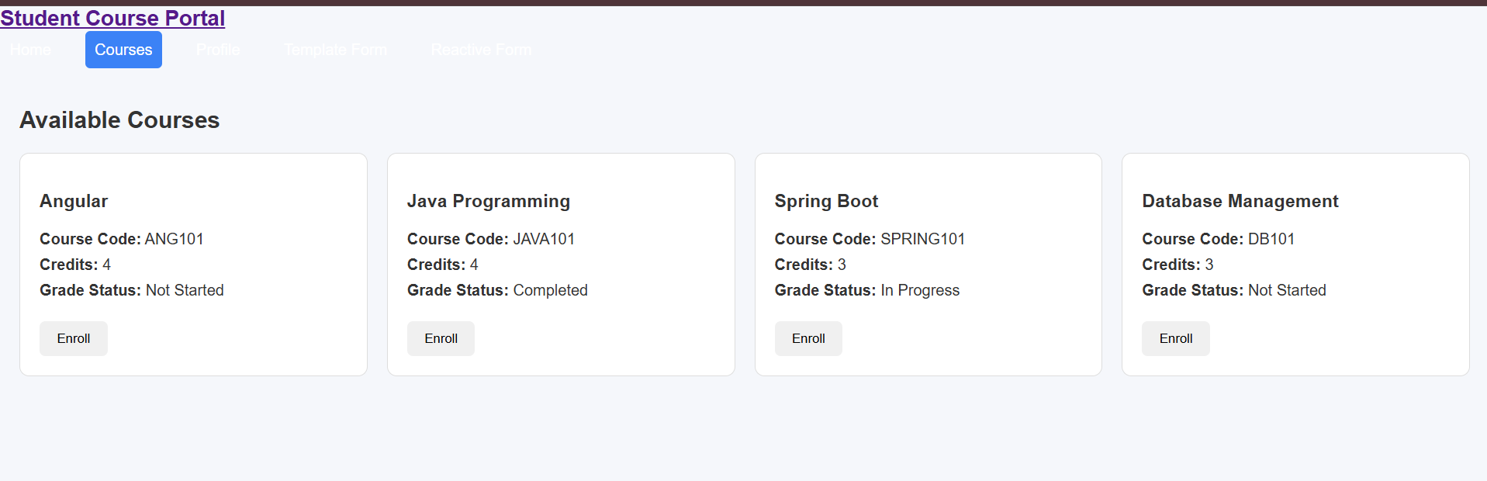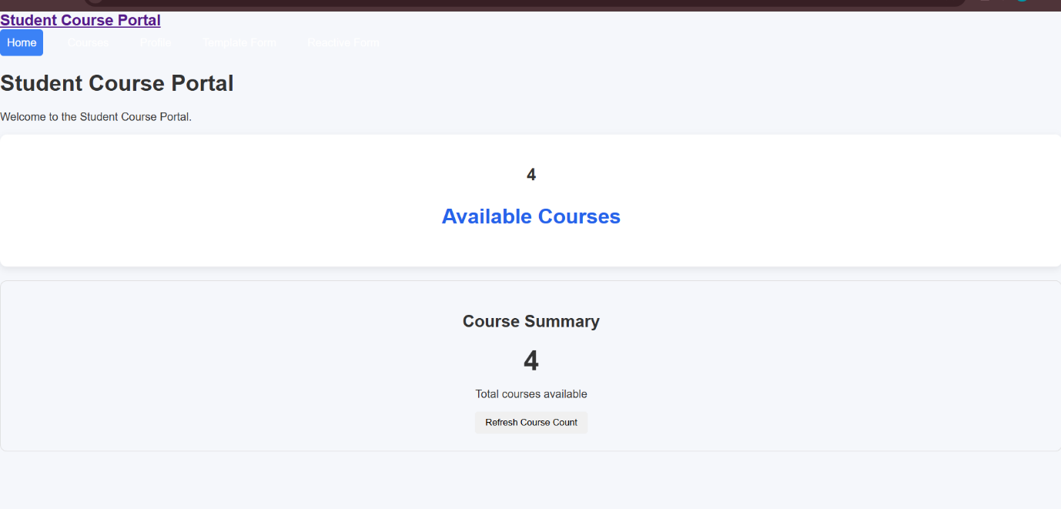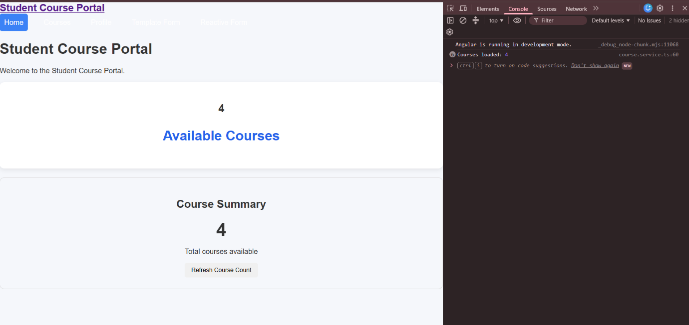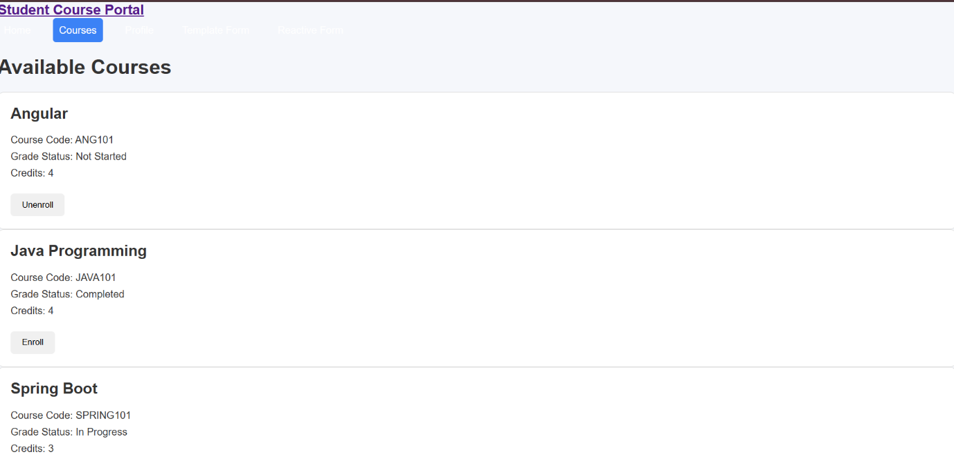

Terminal:
